1. Create a web document that contains the following text:

Use h1 for the title (the first line of text), p for text (the second and third lines of text). Insert a horizontal rule between the h1 element and the p element. Open your new document in a web browser to view the marked-up document.

1. Create a web document containing an ordered list of three items—ice cream, pizza and soft drink. Each ordered list should contain a nested, unordered list of your favourite flavours. Provide three flavours in each unordered list.
2. Create a web page to display a quiz with at least 5 questions. Strictly follow the following instructions.

* Each question should have an ordered question number and 4 options with small alphabets.
* Also give a heading to quiz and highlight important words.
* One question should have use of subscript and superscript elements.
* One question should be in a program format I java, c, python etc.

1. Create an HTML5 document that uses an image as an e-mail link. Use attribute alt to provide a description of the image and link.
2. Create an HTML5 document that contains links to your five favourite E-commerce websites. Your page should contain the heading “My Favourite Shopping Web Sites.” Click on each of these links to test your page.
3. Create a webpage for a book chapter in which all the topic are displayed using ordered list. When user clicks on any topic it should be redirected to corresponding paragraph within same page.
4. Create a web page to display your class time table in tabular format.
5. Create a web page having 9 images arranged in 3\*3 matrixes. When a user clicks on any image, it should open in a new tab.
6. Create a home page for personal website with 4 sections Header, Navigation bar (menu bar), content and footer section. It should have a menu bar for “Bio-Data, Contact, Photos, Notes etc.” For each menu option create a separate web page and link with home page. Structure the web page using HTML table.
7. Modify the webpage created in Exercise-3 using HTML form. Use radio buttons for options, so user can choose only one among 4 options. Also add a submit button for quiz submission.
8. Create a user feedback page which asks questions about a software product. You are required to use checkbox, radio buttons, and drop-down, textarea and various text input type for this. Structure the web page using HTML table.
9. Create an autocomplete input element with an associated datalist that contains the days of the week.
10. Create Write an external style sheet to format the web document of Exercise 1 to apply following effects:
    1. Put a background color and image with gradient overlay.
    2. Make h1 heading 30px, bolder, use color according to your background.
    3. Paragraphs should have font size 15px and choose color according to background.
    4. Increase line spacing in paragraph text.
    5. Highlight important words and use styling for that.
    6. Make h2 heading 20px and choose color according to background.
11. Create a webpage that displays your favourite quotations in a web page just above images. You have to use border, height, width, margin, padding, outline properties of CSS. Also use text and font properties to add effects in text to display quotations.
12. Make a layout template that contains a header and two paragraphs. Use float to line up the two paragraphs as columns side by side. Give the header and two paragraphs a border and/or a background color so you can see where they are.
13. Build a simple horizontal navigation bar using an unordered list and Internal CSS.
14. Create a transformation program that includes four images.When the user mouse hover an image, the size of the image should increase by 20%.
15. Create a Home Page for Banasthali's Website look like following website.

<https://gsas.harvard.edu/>

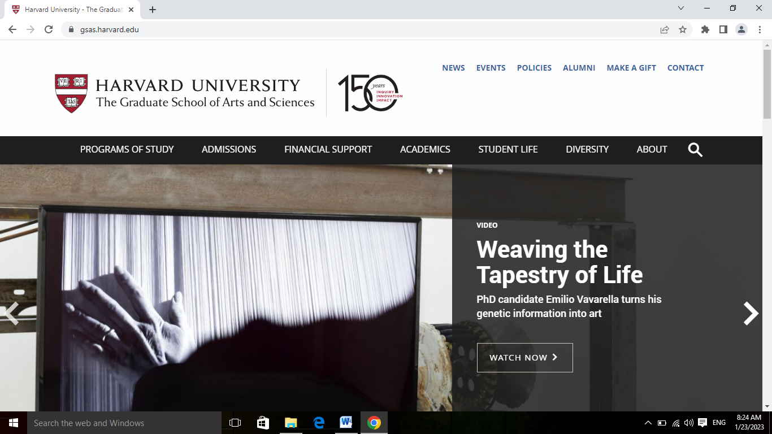

Menu should be

About Us | Academics | Research | Campus & Facilities | School Education | Admissions

And top bar should be

News & Events| International | Careers| Placements |Alumni | Contact Us| Login Hub

You should use your own color scheme and background only the layout should be followed.

1. Implement a Javascript function that accept number of rows(m) and columns(n) from user and displays a 2D m x n square layout of alternate colors black and red.
2. Create a Webpage with two buttons start and stop. When user click on start button a timer should start to count seconds. When a user click on stop button then it should stop.
3. Create a Webpage to display digital clock that display updated time of your system without refreshing webpage.
4. Write a JavaScript to display greeting message according to time with user name that is accessing the webpage. When user clicks on the greeting message it should hide.
5. Write a JavaScript code that displays text “TEXT-GROWING” with increasing font size in the interval of 100ms in RED COLOR, when the fontsize reaches 50pt it displays “TEXT-SHRINKING” in BLUE color. Then thefont size decreases to 5pt.
6. Create a web page to display events in card layout. An event should have image, title, date and description fields. Store all these values in Javascript array or object for multiple events and generate dynamic cards for each events on webpage.
7. Create a Web page that accept a value in a text box for temperature in one unit and convert it to another. It should accept input in kelvin, Celsius, Fahrenheit and Convert accordingly.

26.Create a user registration form which accepts first name, last name (not mandatory), user ID (Banasthali ID), password, confirm password, Address, Email ID, Contact number. Apply appropriate client side validations using JavaScript for all fields of html form. Also layout this form using a CSS.